
3D Visualisation of Satellite Imagery
Prototype Report
Team Imagery
Damian Brockie
Rowan James
Shane Kingston
Matthew McKellar-Spence
Dafydd Williams

Contrast Stretch / Brightness Window
The Contrast Stretch / Brightness Window is an interface for changing the appearance of the displayed image in the Image Window and is used to enhance the appearance only. It will not affect any data.

Stage 1

Description
- This prototype is accessed from the toolbar menu in the Overview window.
- The window on the left appears first and gives controls for the Brightness and contrast over the whole image.
- RGB colour range is the control for contrast stretch. Selecting ‘Manual’ and clicking ‘Edit Colour Range’, will bring up the window on the right.
- The window on the right displays a histogram for each channel with a slider for selecting the range.

Stage | Previous Stage | Developer
1 | None | Shane
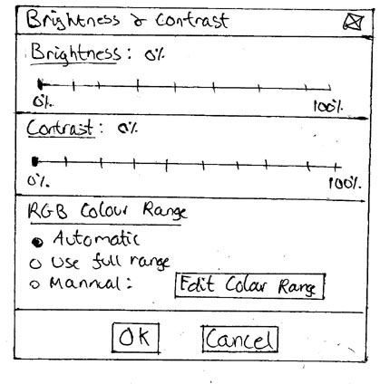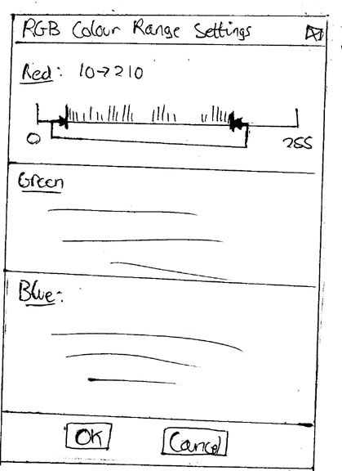

Feedback
Nil

Status
Another stage required

Stage 2

Description
- This prototype is accessed via the toolbar menu on the Overview window.
- It is based on the Photoshop style for the same operation.
- There are 2 options, 1 for adjusting a single channel or entire image and one for individually adjusting multiple channels.

Stage | Previous Stage | Developer
2 | None | Dave
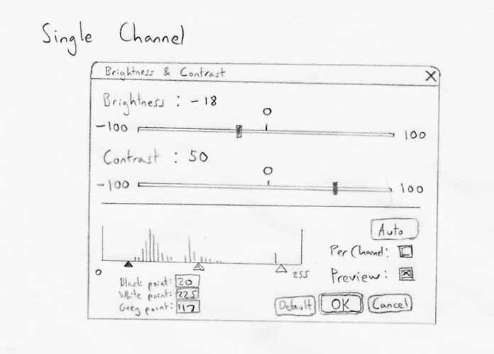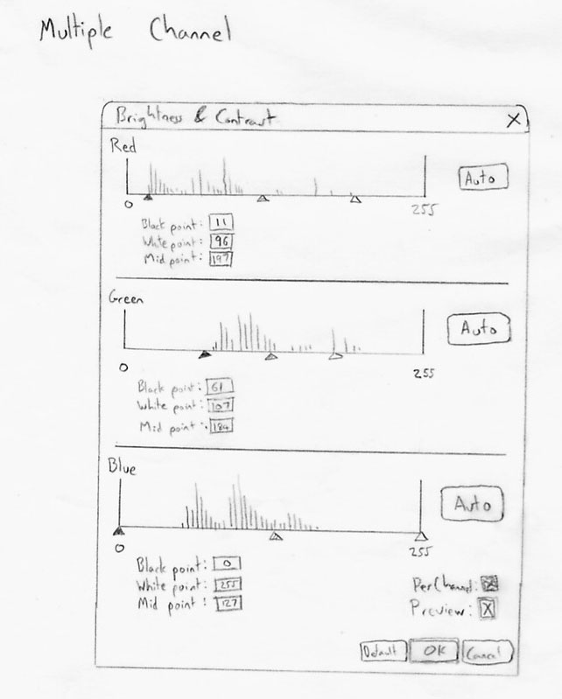

Feedback
Good
- I like the histogram
Improve
- How does one get from single to multiple channels? Perhaps an advanced/basic control button.
Francis Chui (Krill)

Good
- Providing the histogram style display is nice (although I presume the intended audience would know what it means).
- Default button is good, as is preview.
Improve
- How is auto different from defaults?
- The brightness/contrast numbers (-100, 100) mean what?
Michael Ford (BioDiv)

Status
Another stage required

Stage 3

Description
- This prototype is accessed via a tab in the Tools window.
- The user is first presented with a basic view for adjusting the brightness and contrast of the entire image.
- Upon selecting the Advanced button, the user presented with advanced options (right window). The user can then adjust the Brightness and Contrast individually for each displayed channel.

Stage | Previous Stage | Developer
3 | none | Damian
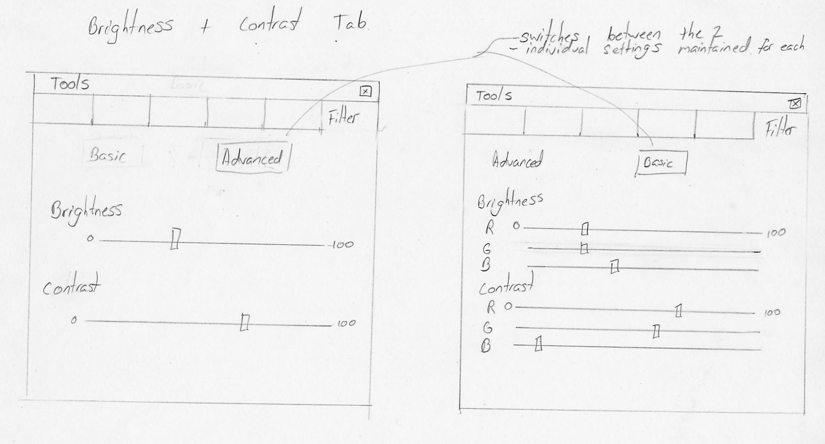

Feedback
Good
- Intuitive and basic with sliders. I like the ability to switch between RGB and all channels
Improve
- Buttons switching might get annoying.
- Maybe have one window and switching between basic/advanced will either lock or unlock the three channels.
- Could add a spinner/textbox for numerical input.
Francis Chui (Krill)

Good
- Having it as a separate tab is good
Improve
- How does changing RGB values change the overall values (if I changed values in 'advanced' and switch to 'basic' where would the slider be).
- What is the number 800, percentage?
- How about a defaults button?
Michael Ford (BioDiv)

Status
Another stage required

Stage 4

Description
.
Stage | Previous Stage | Developer
4 | 1, 2 and 3 | Whole Team

Feedback
Nil

Status
Approved by most people and finished

Preferences Window
The Preference window is for setting custom user settings such as, Memory Usage, Various incremental control settings, Display settings, shortcuts, default settings, etc.

Stage 1

Description
- This Prototype is a tabbed layout accessed from the toolbar menu in the Overview window.
- There are separate tabs for Memory Usage, Defaults and Shortcuts.

Stage | Previous Stage | Developer
1 | None | Shane
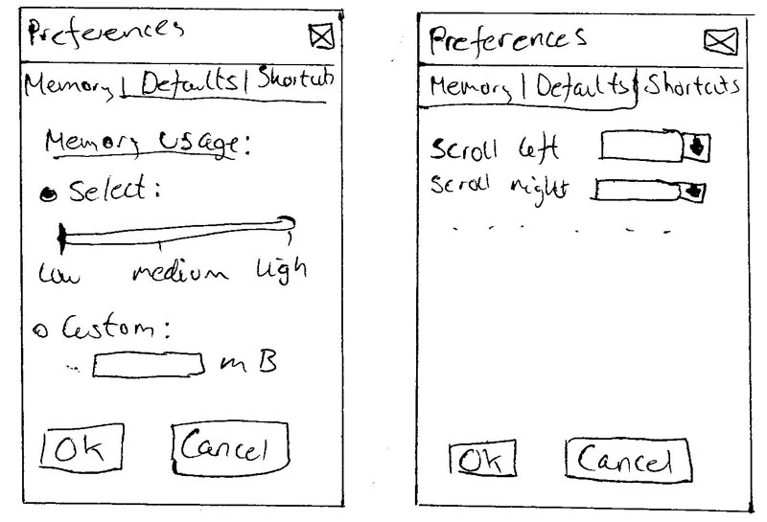

Feedback
Nil

Status
Another stage required

Stage 2

Description
- This Prototype is accessed via the toolbar menu on the Overview window.
- A tree structure is used to access different settings.
- Clicking on an item in the tree will highlight it and change the pane on the right to display the relevant options for those settings.

Stage | Previous Stage | Developer
2 | None | Matt
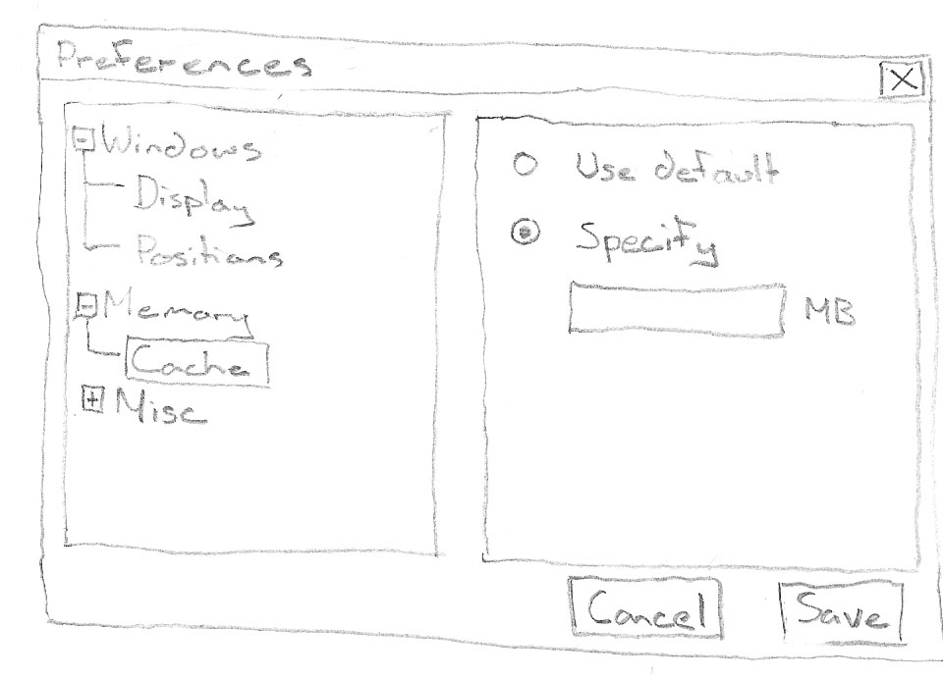

Feedback
Good
- Tree structure is good for the layout.
Improve
- A separate page displaying information on selected sections would help with usability.
Francis Chui (Krill)

Good
- Use tree menu
Kade Hylord (Krill)

Status
Another stage required

Stage 3

Description
- This Prototype will be accessed via the menu toolbar on the Overview window.
- A tree structure is used to access different settings.
- Clicking on an item in the tree will highlight it and change the pane on the right to display the relevant options for those settings.
- Items available in the tree structure will be:
  - Layout, which has default options selected via radio buttons.
  - Shortcut keys, for binding different keys to different shortcuts.
  - Memory Usage, will set how much memory Parbat will utilise.

Stage | Previous Stage | Developer
3 | 1 and 2 | Whole Team
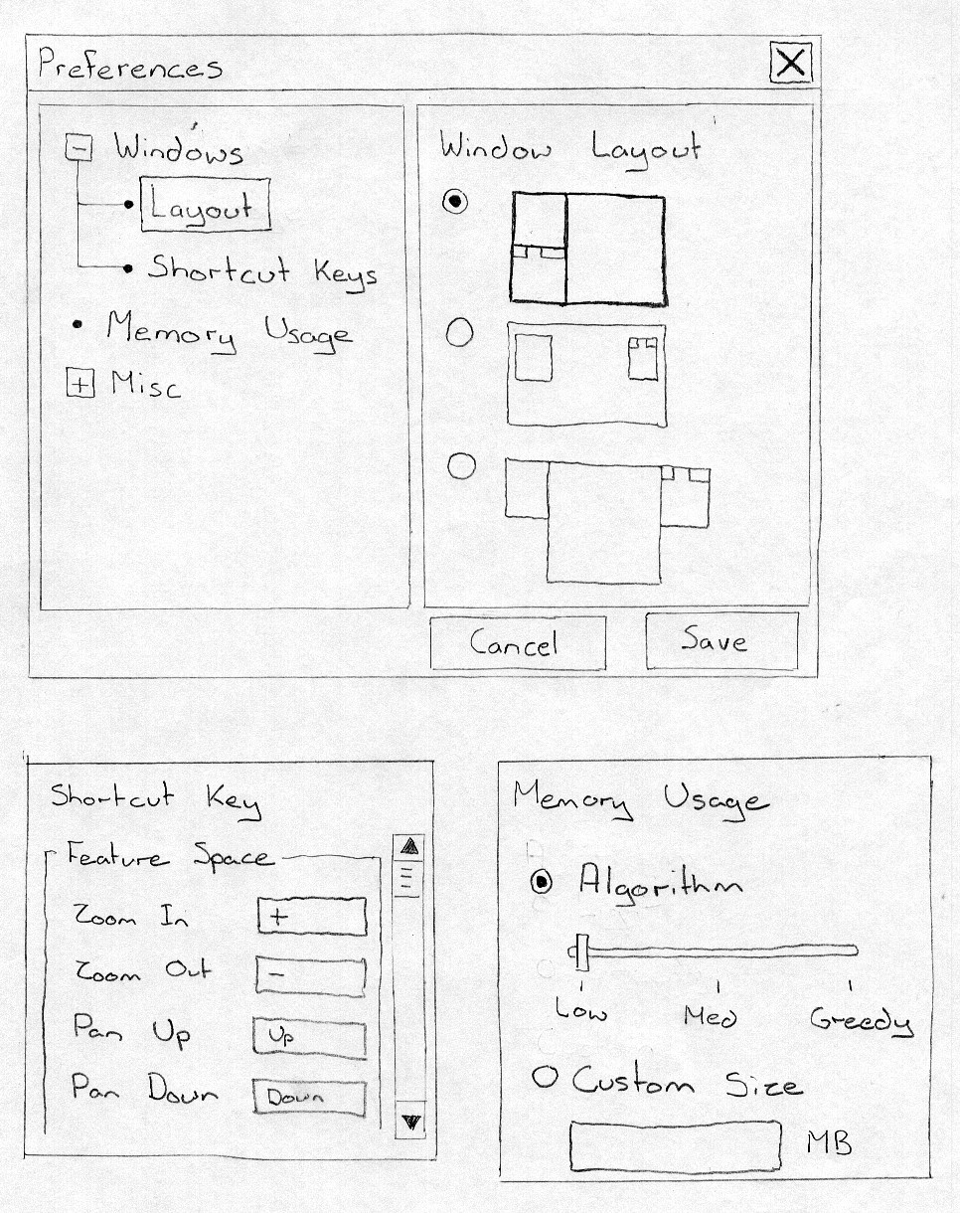

Feedback
Nil

Status
Approved by most people and finished

ROI Creation Window
The ROI creation Window is used to create, save, load and view Regions Of Interest (ROIs). ROIs will be able to have colours associated with them which will show in the Image window and in the Scatter Plot on the Feature Space window.

Stage 1

Description
- This Prototype is accessed via the Tools window.
- To define a new ROI, the ‘define new’ button is clicked and it will appear to be pushed in until an ROI has been created, or until the button is clicked again to cancel it.
- Everything else in the Tool window is disabled while the Define New button is pushed in.
- The user is prompted with instructions via the status bar.
- The user clicks on the image window to define points.
- When all points are connected, the ROI is added to the list & squares marking the points on the image window are removed.
- As the mouse is moved over the different controls (i.e. the buttons, ROI names, etc), tooltips are displayed in the status bar.
- The user double clicks on an ROI name to change it.

Stage | Previous Stage | Developer
1 | None | Shane
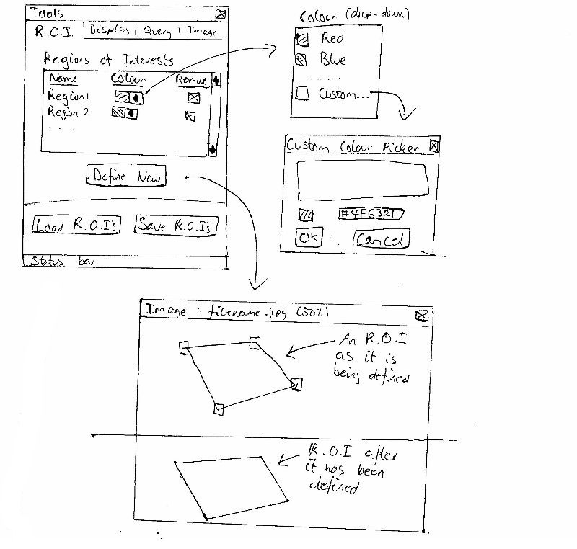

Feedback
Nil

Status
Another stage required

Stage 2

Description
- This prototype is accessed via the toolbar menu on the overview window.
- When a new region is created it is added to the list in the ROI window.
- A random colour is assigned to the ROI.
- Visibility of the ROI in the image window is controlled via the checkbox and is enabled by default.
- The colour assigned to the ROI is changed via a dialogue window after double clicking on the colour box.
- The ROI name can be changed by double clicking on it.
- The save button prompts the user to select a file to which selected ROIs can be saved (to our file format).
- The Load button prompts the user to select a file to merge with the current ROI list.
- The Trash button or the Delete key (after conformation) deletes selected ROIs from the list.
- The Black/White button inverts selection.
- Active ROIs are drawn translucently with their coloured lines in the Image window.
- Other 2 buttons enable creation of ROIs interactively as either rectangular or arbitrarily shaped polygons.
- Shift Key locks Polygonal creation tool to 15° snap.

Stage | Previous Stage | Developer
2 | None | Rowan
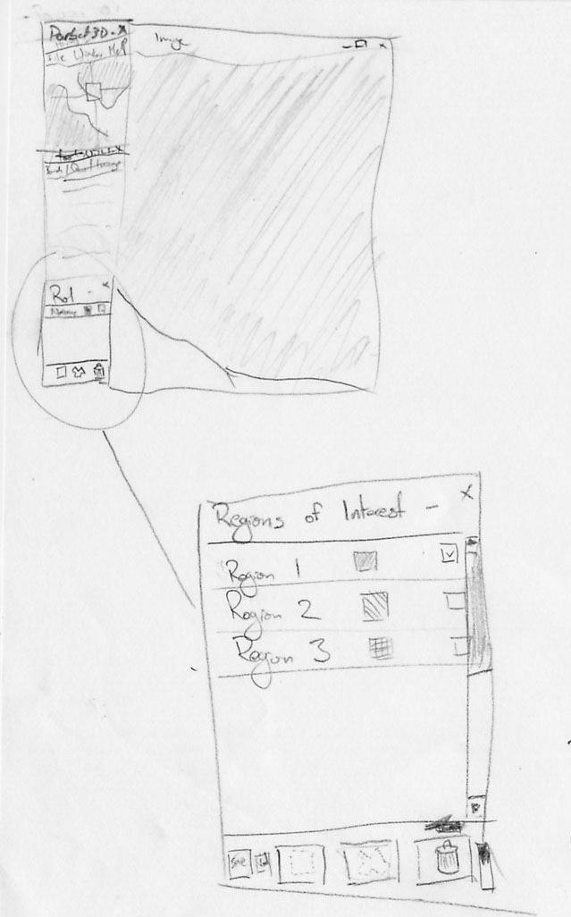

Feedback
Nil

Status
Another stage required

Stage 3

Description
- This prototype for ROI creation utilises a toolbar that is snapped to the image window.
- It can be toggled on and off via the toolbar menu on the Overview window.
- The loaded or created ROIs are accessed via a dropdown menu.
- ROIs can be loaded or created using buttons.

Stage | Previous Stage | Developer
3 | None | Matt
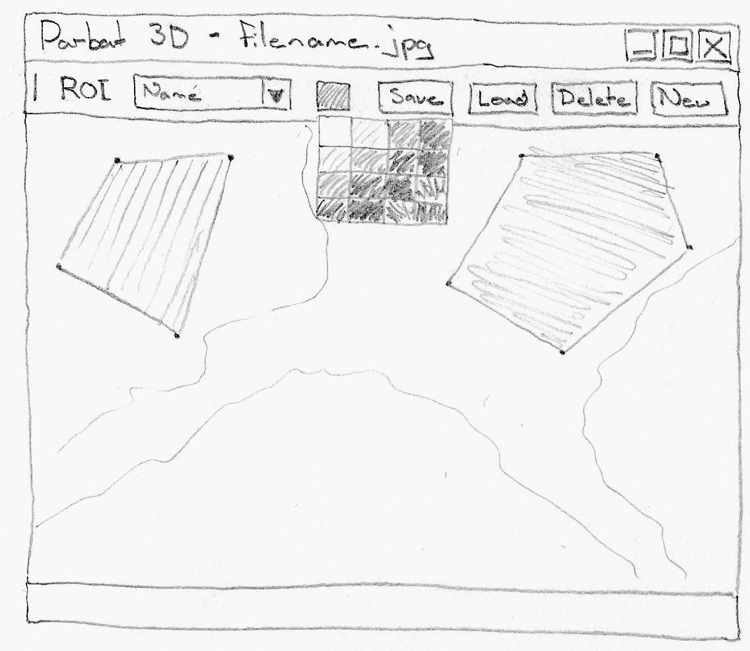

Feedback
Good
- Better incorporation with the image when placing ROI creation toolbar in window.
Improve
- Needs some feedback of which ROI is selected.
Francis Chui (Krill)

Status
Another stage required

Stage 4

Description
- This prototype is accessed via a tab on the Tools window.
- The lower section of the ROI tab is for defining new ROIs.
- To Define a new ROI, the user enters a name and chooses a colour. The ‘Define’ button will become activate. The user then clicks each point of a polygon in the Image window to create a region. To close and complete the region, the first point is clicked again.
- ROIs can be loaded at any time.
- A user can select an existing ROI and click ‘Remove’ to remove it, or ‘Save’ to save it.

Stage | Previous Stage | Developer
4 | None | Dave
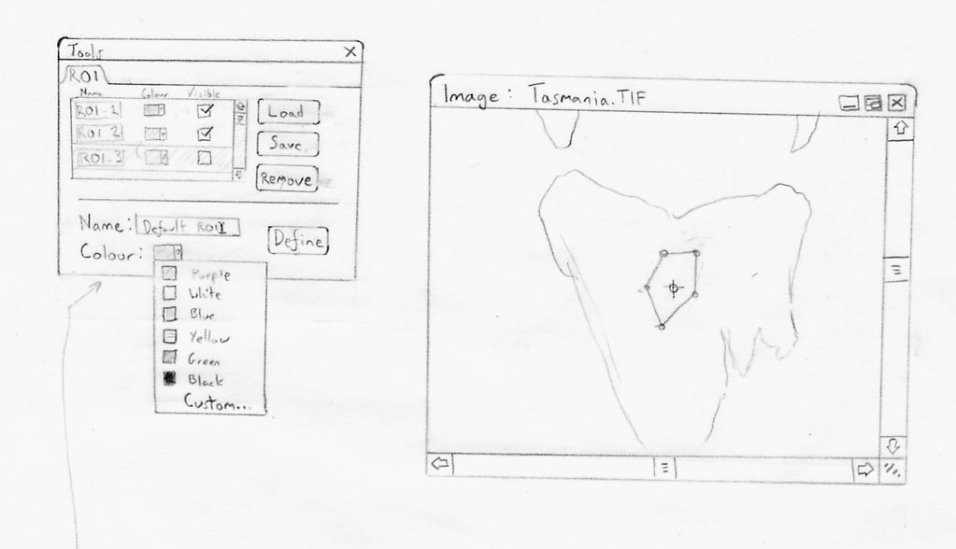

Feedback
Nil

Status
Another stage required

Stage 5

Description
- This prototype is accessed via a tab on the Tools window.
- Upon selecting ‘New’, the ‘save’ and ‘Cancel buttons will become active and the cursor will change to a crosshair.
- Each point is selected with a mouse click. Delete will remove a single point.
- Escape or ‘Cancel’ to will cancel the create ROI operation.
- Upon closing polygon, the user can then select ‘Save’ (standard save window). The ROI will then appear in the list.

Stage | Previous Stage | Developer
5 | None | Damian
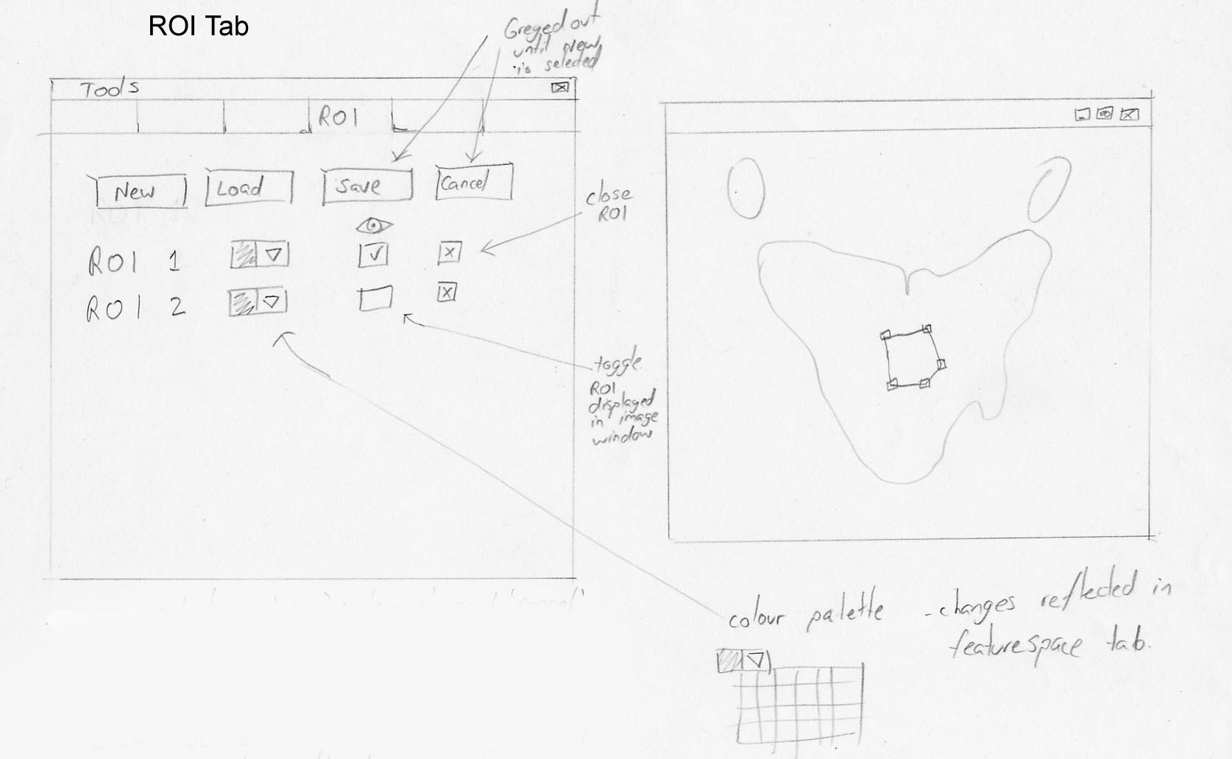

Feedback
Good
- I like how new ROI will be added one after another
Improve
- Having the close/view ROI next to each other would get annoying with accidental clicks.
Francis Chui (Krill)

Status
Another stage required

Stage 6

Description
- This prototype is accessed via the toolbar menu on the Overview window.
- When a new region is created it is added to the list in the ROI window.
- A random colour is assigned to the ROI.
- Visibility of the ROI in the image window is controlled via the checkbox and is enabled by default.
- The colour assigned to the ROI is changed via a dialogue window after double clicking on the colour box.
- The ROI name can be changed by double clicking on it.
- The save button prompts the user to select a file to which selected ROIs can be saved (to our file format).
- The Load button prompts the user to select a file to merge with the current ROI list.
- The Trash button or the Delete key (after conformation) deletes selected ROIs from the list.
- Active ROIs are drawn as outlines in the Image window.
- Other 2 buttons enable creation of ROIs interactively as either rectangular or arbitrarily shaped polygons.

Stage | Previous Stage | Developer
6 | 1, 2, 3, 4 and 5 | Whole Team
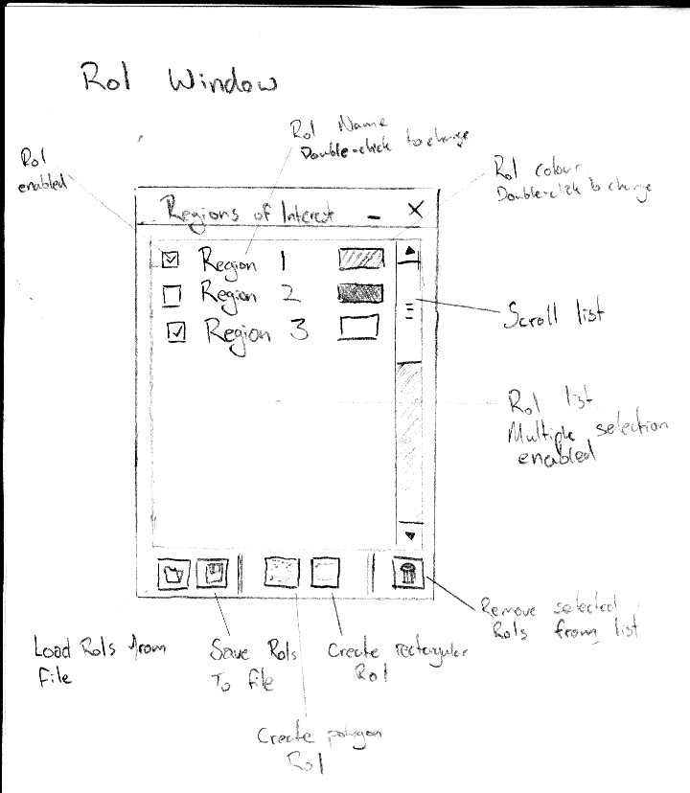

Feedback
Nil

Status
Approved by most people and finished

Feature Space Creation Window
The Feature Space Creation Window is used to set-up and create the Feature Space Window which displays a user defined Scatter Plot. Scatter Plots can be created using the whole image, just the ROIs or the whole image with ROIs highlighted. Each display channel (RGB) can be assigned a band to be displayed in the Scatter Plot.

Stage 1

Description
- This Prototype is accessed via a tab in the Tools window.
- Radio buttons are used for display options.
- ROIs are selected via check boxes.
- Any image band can be assigned to an axis in the scatter plot via radio buttons.
- The create button displays the feature space.

Stage | Previous Stage | Developer
1 | None | Shane
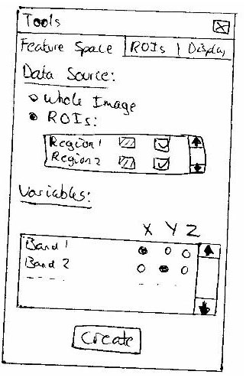

Feedback
Nil

Status
Another stage required

Stage 2

Description
- This prototype is accessed via a tab on the Tools window.
- An axis can be assigned any or no band via radio buttons.
- The check box sets the option to only show active ROIs.
- The granularity is selected via a slide bar and the number of points are displayed accordingly.
- Generate button creates new visualisation window with set (static) configuration.
- Active ROIs (if any) will always be drawn in their preset colour.

Stage | Previous Stage | Developer
2 | None | Rowan
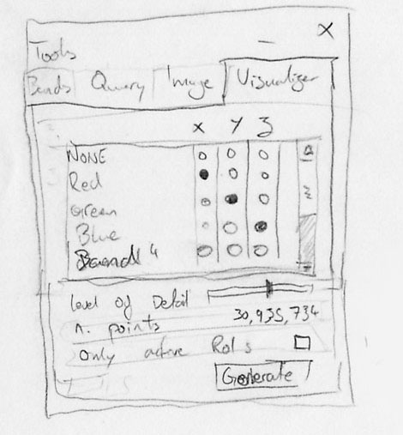

Feedback
Nil

Status
Another stage required

Stage 3

Description
- This prototype is accessed via the toolbar menu on the Overview window.
- Display options are chosen via radio buttons
- Any image band can be assigned to an axis in the scatter plot via radio buttons.
- The create button displays the feature space.

Stage | Previous Stage | Developer
3 | None | Matt
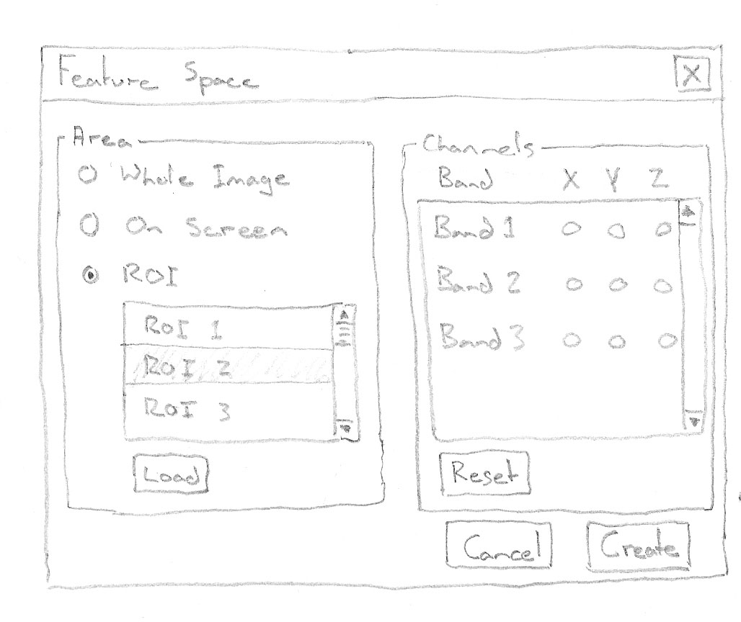

Feedback
Nil

Status
Another stage required

Stage 4

Description
- The Granularity is entered manually via a text field.
- If the ‘Entire image’ checkbox is ticked only, the Scatter Plot will be of the entire image’
- If an ‘ROI’ checkbox (1 or more) is ticked only, the Scatter Plot will be of the selected ROIs only and displayed with selected colours.
- If the ‘Entire Image’ checkbox and an ‘ROIs’ checkbox (1 or more) is ticked, the Scatter Plot will be of the entire image with the ROIs represented by selected colours and the remaining points will be white.
- Bands that are displayed in the image window that are chosen in the Channel Selection tab can be assigned to any or the x, y and z axis.
- ROIs can be assigned an individual colour for the Scatter Plot that differs from that in the Image window.

Stage | Previous Stage | Developer
4 | None | Damian
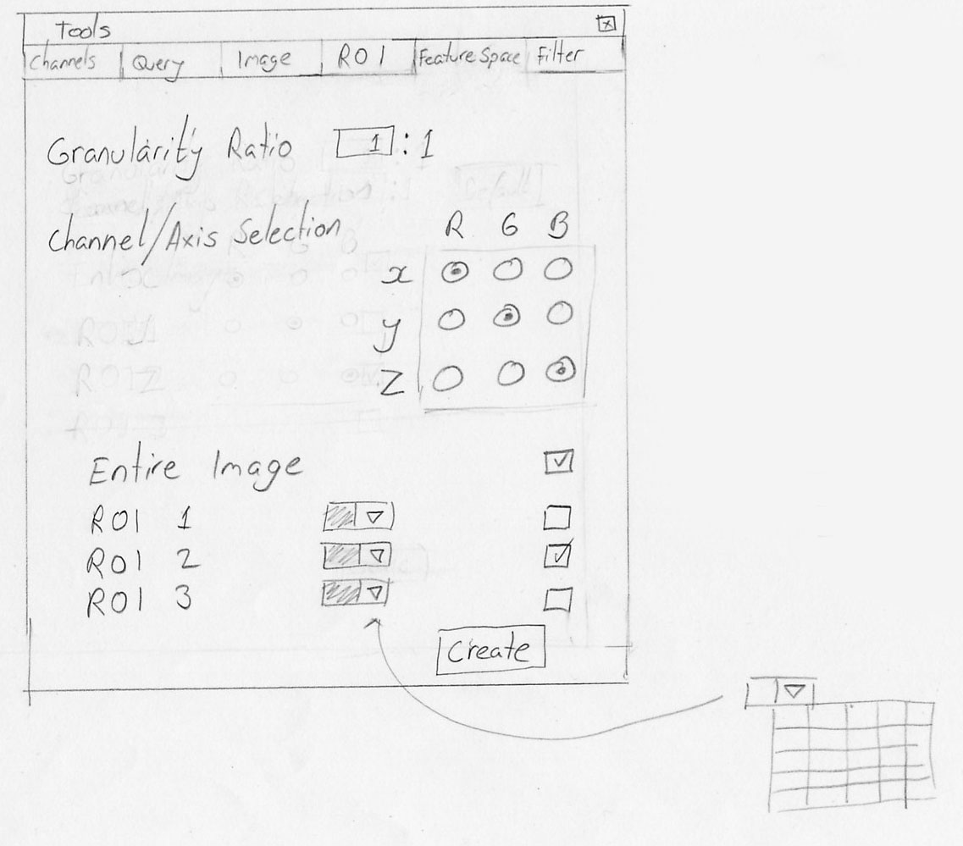

Feedback
Improve
- Tabs seem a little confusing.
- With channel/axis selection.
- Granularity ratio could use a spinner as well as the textbox
Francis Chui (Krill)

Status
Another stage required

Stage 5

Description
- Any image band can be assigned to an axis to be displayed in the Scatter Plot.
- The granularity is set via a slider with preset binary values which in turn updates the number of points value.
- If the Active ROIs checkbox is ticked, the Scatter Plot will display only ROIs that are loaded in the ROI window.
- If the Active ROIs checkbox is unticked, the Scatter Plot will display the entire image with active ROIs that are loaded in the ROI window displayed in their respective colours. If there are no active ROIs, only the entire image will be displayed in the Scatter Plot.

Stage | Previous Stage | Developer
5 | 1, 2, 3 and 4 | Whole Team
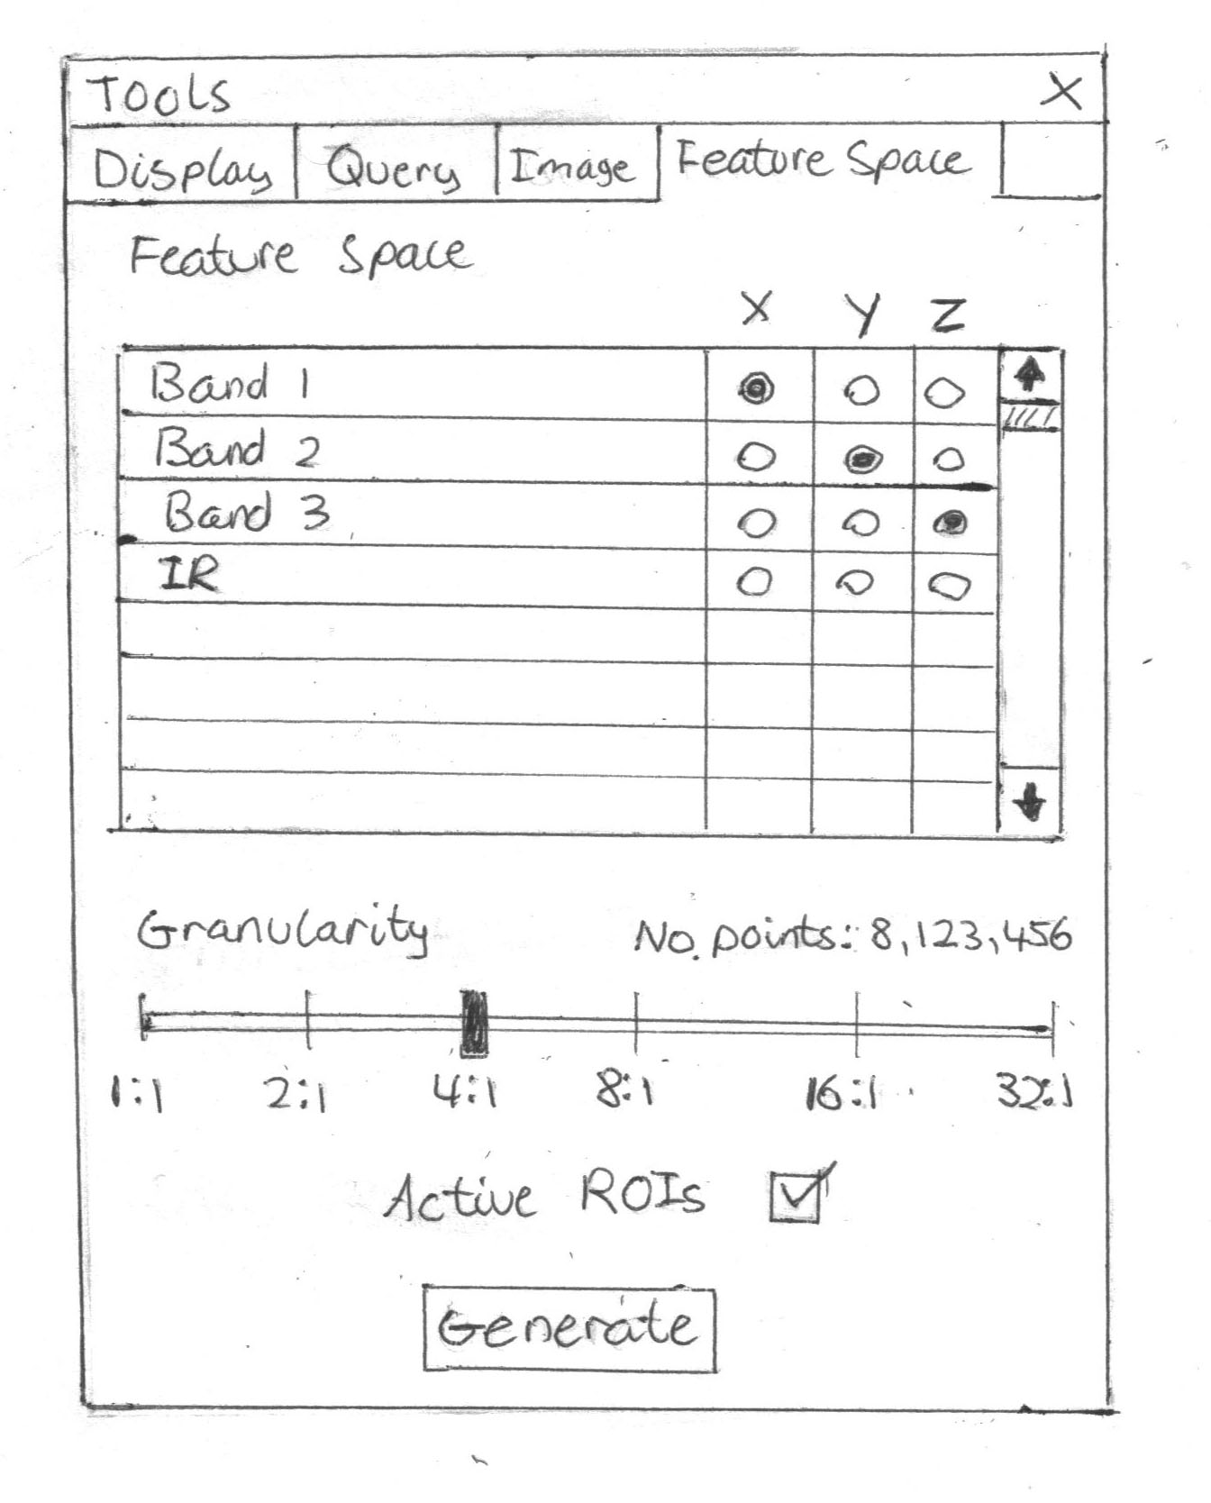

Feedback
Nil

Status
Approved by most people and finished

Feature Space Window
The Feature Space window will display a predefined Scatter Plot. Each point in the Scatter Plot represents the pixel values from chosen image channels along the x, y or z axis. The user will be able to zoom, pan and rotate the Scatter Plot.

Stage 1

Description
- The status bar displays information on what the buttons do when the mouse is moved over them.
- The Feature Space control buttons are Rotate, Left/Right/Up/Down and Zoom in/Zoom out.
- The ROIs highlighted are indicated via an index in the top right corner.

Stage | Previous Stage | Developer
1 | None | Shane
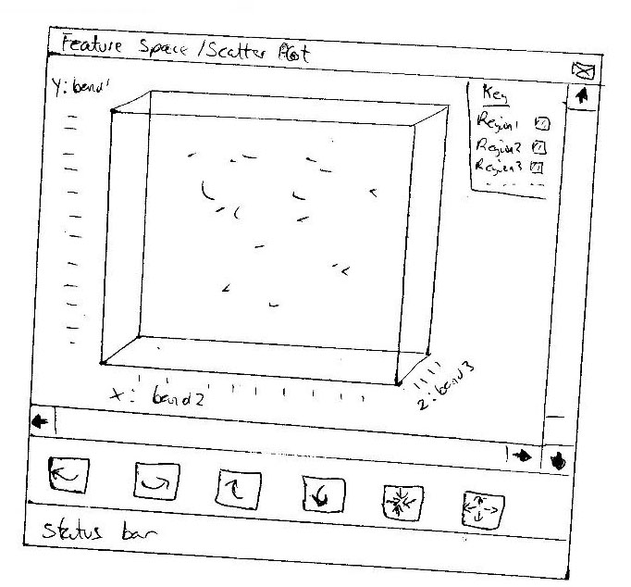

Feedback
Good
- Buttons for control of scatter plot rotation.
Francis Chui (Krill)

Status
Another stage required

Stage 2

Description
- This prototype is accessed via the ‘Generate’ button on the Feature Space Creation tab on the Tools window.
- Bands associated with each axis, the granularity and number of points are displayed in the bottom left corner.
- All navigation controls are accessed via shortcuts or the mouse.

Stage | Previous Stage | Developer
2 | None | Rowan
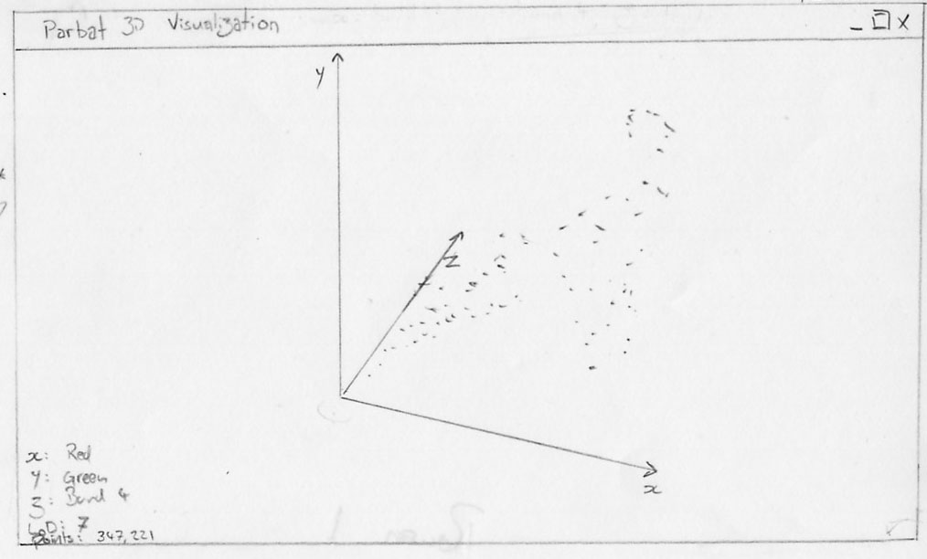

Feedback
Nil

Status
Another stage required

Stage 3

Description
- This prototype is designed to be simplistic.
- It is accessed by pressing the create button on the feature space creation window.
- An axis direction indicator is displayed in the bottom right and rotates as the image is rotated.
- The status bar contains a progress bar for Scatter Plot creation.
- All controls are accessed via shortcuts or the mouse.

Stage | Previous Stage | Developer
3 | None | Matt
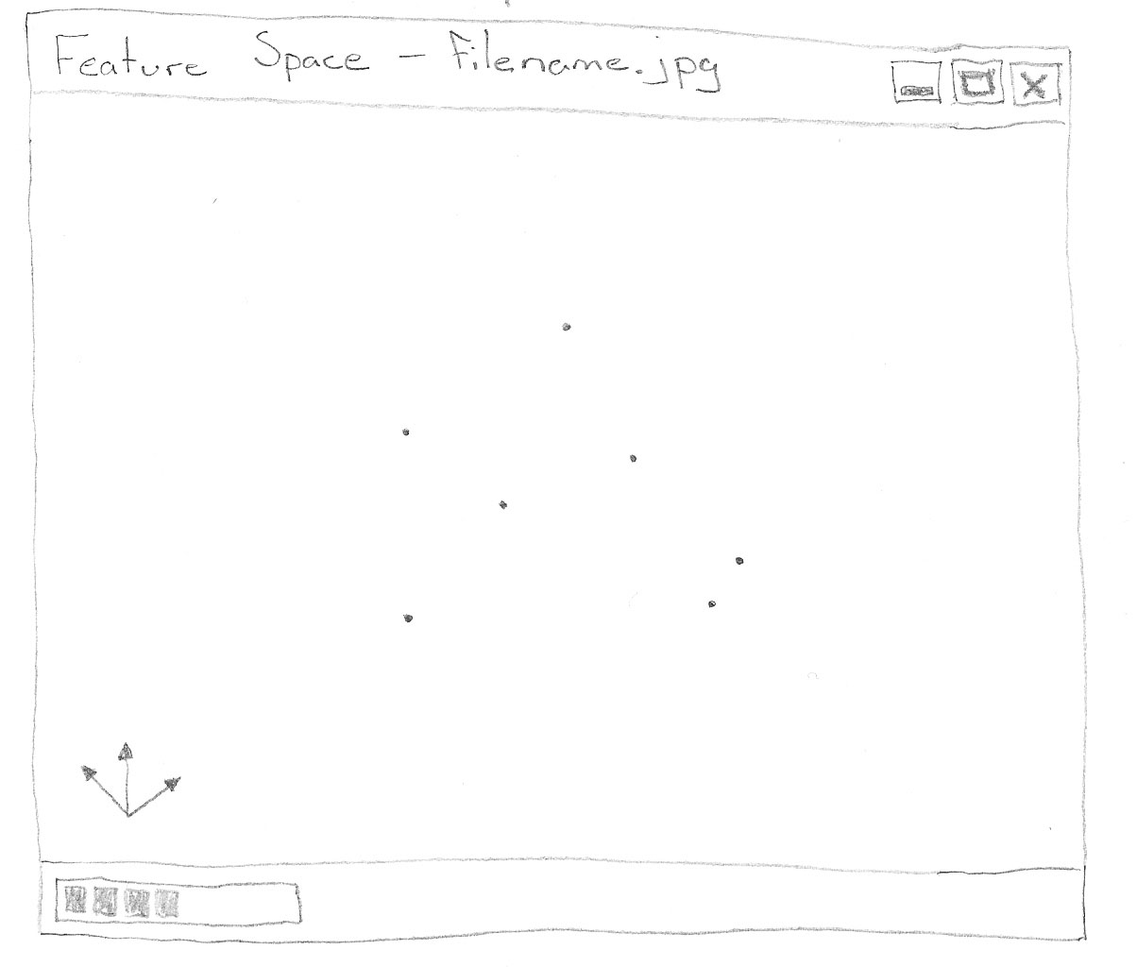

Feedback
Good
- Display of axis is good
Improve
- Will scatter be able to be rotated? If origin is the centre would get confusing with axis off centre when that spins as well.
- A bounding box like Damian's design would help.
Francis Chui (Krill)

Status
Another stage required

Stage 4

Description
- This prototype is accessed via the ‘Create’ button on the Feature Space Creation tab on the Tools window.
- Bands associated with each axis are displayed in the top left corner.
- Navigation controls are Rotate left and right, Rotate up and down, Pan in any direction, Zoom in and Zoom out.
- For the Rotate and Zoom buttons, the user simply clicks and holds on the button and drags in the appropriate direction.
- The granularity is displayed in the right of the status bar.

Stage | Previous Stage | Developer
4 | None | Dave
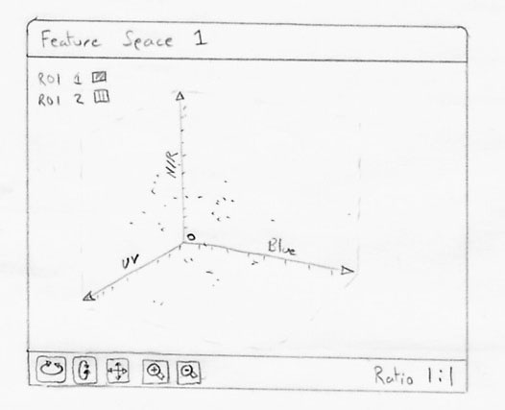

Feedback
Nil

Status
Another stage required

Stage 5

Description
- The ROI index that is displayed in the top left can be toggled on and off in the status bar.
- The granularity of the Scatter Plot can be updated via the status bar.
- The scroll wheel on the mouse will zoom in and out.
- To rotate in any direction the user must left click the mouse and drag in the appropriate direction.
- To pan in any direction the user must right click the mouse and drag in the appropriate direction.

Stage | Previous Stage | Developer
5 | None | Damian
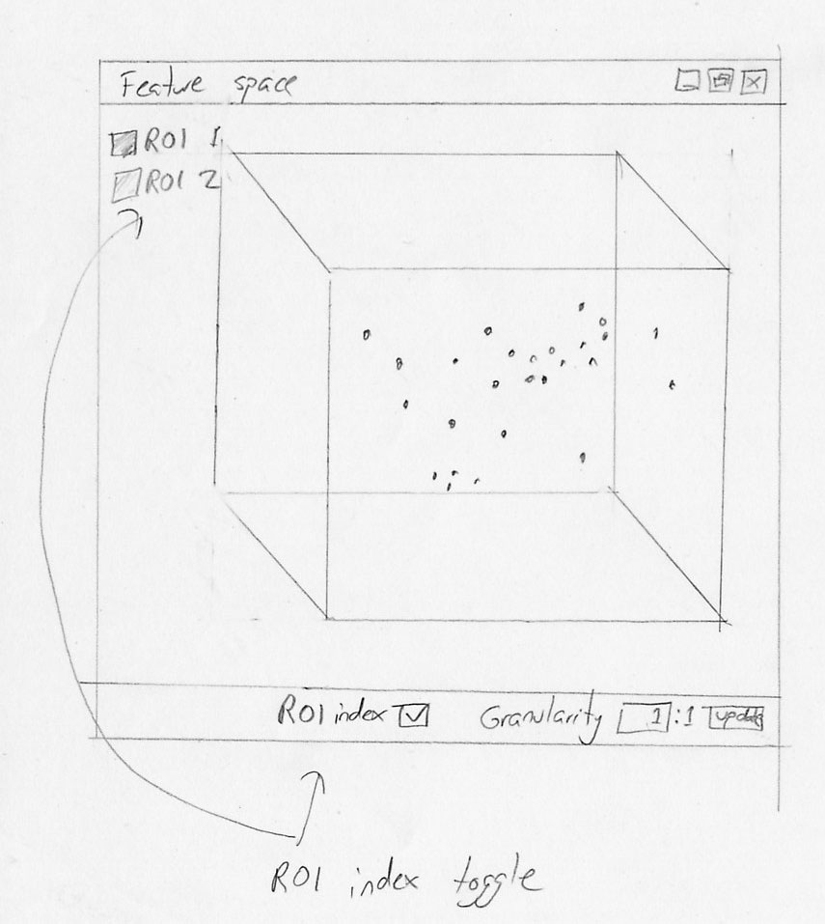

Feedback
Good
- Simple and well laid out window
Improve
- Depth cue for scatter plot with the use of brightness variation with depth. This would allow the user to view location of a point without constant spinning of the plot (point relative to surrounding).
Francis Chui (Krill)

Status
Another stage required

Stage 6

Description
- This prototype is accessed via the generate button on the Feature Space Creation tab on the Tools window.
- The window will open and the progress bar will visually show how long until the Scatter Plot is loaded.
- The ROI index that is displayed in the top left can be toggled on and off in the status bar.
- The scroll wheel on the mouse and 2 of the buttons on the status bar will zoom in and out.
- The arrow buttons on the status bar will rotate the Scatter Plot in any direction.
- To pan in any direction the user must left click the mouse and drag in the appropriate direction.
- In the very right of the status bar are 3 options for displaying a Bounding Cube, 3 way Axis or Nothing around the Scatter Plot.

Stage | Previous Stage | Developer
5 | 1, 2, 3, 4 and 5 | Whole Team
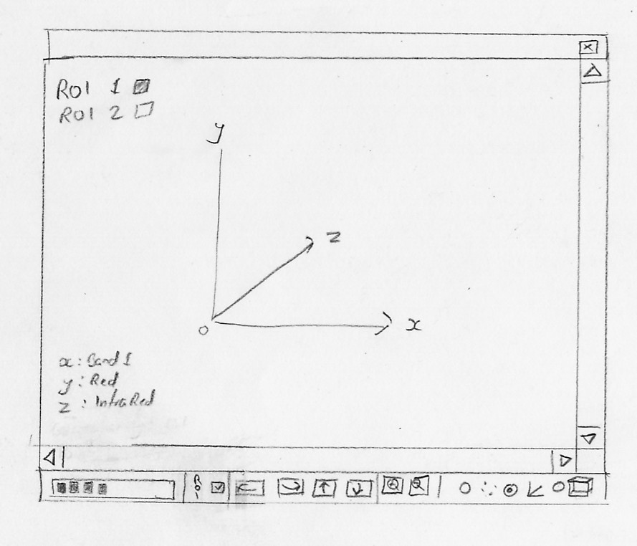

Feedback
Nil

Status
Approved by most people and finished

